**HTML - Session 4 Breakout**

In your groups, you will collaborate to work on these git activities together. You will take turns sharing your screen, and creating a web page together - as well as practicing GitHub collaboration.

**Activity objectives:**

* Practice Teamwork.
* Practice Communication.
* Learn Key Researching Skills
  + How to figure out tags and CSS properties you are unfamiliar with
  + Problem solving when you get stuck without checking answers
* Creating well structured webpages using:
  + Paragraphs
  + Headings
  + Images
  + Anchor Links
  + Tables
  + Contact Forms & input validation
  + Radio Buttons
  + Semantic HTML

**If you get stuck:** Remember, Google is your friend! The more you practice researching, the easier it will get to find what you need.

**Team member 1**

1. As a team, you need to have one person create a repository called **HTML-Debrief.**
2. **Share the URL HERE => Or in your chat.**
3. Setup GitHub pages (live site) for the repo, and enter the web address into the table at the bottom of this page.
4. **Move** into the **HTML-Debrief** project**.**
5. In this directory **create** a new html files called **index.html** and **contact.html**.
6. **Open** **index.html** with **VS Code** and **run** your **live server**. This will open your browser to a live preview of your html.
7. Lets begin our html. **Do not** use the !DOCTYPE boiler plate, let’s do it step by step.

**Create** the following tags --

1. **<!doctype>**

2. **<html>**

**Inside** Html --

a. **<head>**

b. **<body>**

1. As we build our html, we will leave **comments** in our code to let us know what components do. **Leave comments for your previous code**, and don’t forget to **comment your new code**.
2. **Inside** the head tag **create** a **<title>** **tag** and copy and paste our project name, HTML-Debrief, inside the tags.
3. **Push** the current data to the **repository** and **share the repository URL in chat**.
4. The team members will now **fork** the main repo on github and **clone** the new repository to your **local** projects folder using the available **URL.**

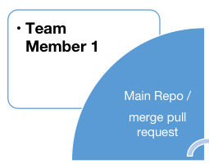

**Team member 2**

1. **Next team mate.**
2. **Create** a new **branch** called **member-2**.
3. Inside our body tag **create** a **<div>** with the **class** “main-container”.
4. Inside main-container **create** a **<h1>** tag with the text “HTML - Debrief” and a **<p>** tag with some random text using our **lorem20.**
5. Underneath your closing **<p>** tag create the tags **<h2>**, **<h3>**, **<h4>**, **<h5>** and **<h6>**. Give them all the same text of “I am sample text”.
6. After that, use your google skills to **create** an **unordered list** with a **class** of “unordered-list” and **insert** three **list item** entries.
7. Again, using your google skills, create an ordered list with an id of “ordered-list” and **insert** three **list item** entries.
8. **Add** and **commit** the new data. Go back to the **main branch** and **merge** the **member-2** branch. Once you have done this **delete the branch member-2**.
9. **Create** a **pull request to team member 1** of the new version of the web site.
10. **Team member 1 - Review, accept** and **merge pull request**.
11. **All of the team** will now perform a **git pull URL** to the repo from **team member 1.**

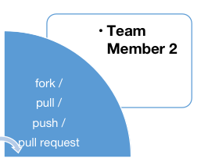

**Team member 3**

1. **Next team mate.**
2. **Create** a new **branch** called **member-3**.
3. **Create** a **<footer>** tag and add an **<a>** tag inside.
4. **Link** the **<a>** tag to google.com and using google find the attribute to open the link in a new page. Copy and paste the text “Click here to search google!” as the visible text.
5. Create a **<table>** tag and using your google skills, give it -

Two **<table>** headings

Three **<table> rows**

1. Dont forget to **work as a team** to find **solutions**.
2. **Add** and **commit** the new data. Go back to the **main branch** and **merge** the **member-3** branch. Once you have done this **delete the branch member-3**.
3. **Create** a **pull request to team member 1** of the new version of the web site.
4. **Team member 1 - Review, accept** and **merge pull request**.
5. **All of the team** will now perform a **git pull URL** to the repo from **team member 1.**

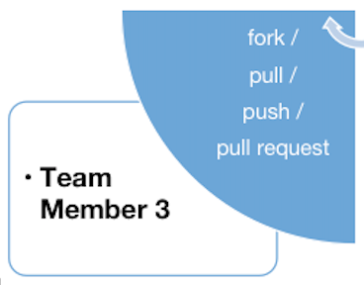

**Team member 4**

1. **Next team mate.**
2. **Create** a new **branch** called **member-4**.
3. **Create** a contact **form** with **Name, Email** and **Telephone** - **Labels** and **input** fields.
4. Dont forget to **work as a team** to find **solutions** andremember google is your friend! **: )**
5. **Leave place holder** text in the **input** fields.
6. The form **must contain** -

Two **<radio>** buttons

Three **<checkbox>** options

A Submit **<button>**

1. **Add** and **commit** the new data. Go back to the **main branch** and **merge** the **member-4** branch. Once you have done this **delete the branch member-4**.
2. **Create** a **pull request to team member 1** of the new version of the web site.
3. **Team member 1 - Review, accept** and **merge pull request**.
4. **All of the team** will now perform a **git pull URL** to the repo from **team member 1.**

